

Chinook Music Store

User Manual

Internet Scripting Coursework Two

B00413005

Contents

Home Page 3

Album view 3

Insert Album 3

Details 4

Update 4

Delete 5

## Home Page

Chinook Music Store website allows employees to manage albums, artists and tracks digitally. Employees can view all available albums by selecting ‘Albums’ in the main navigation bar.

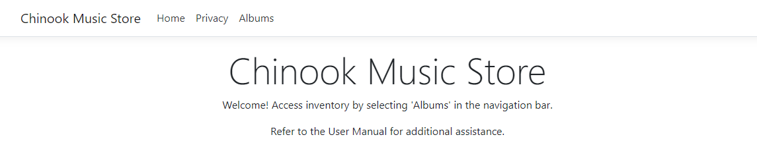

## Album view

All available albums and their artists are displayed in a table, which is sorted by artist name alphabetically. New albums can be inserted by selecting ‘Insert Album’. Additional functionality related to specific albums can be accessed at the end of each row of the table.

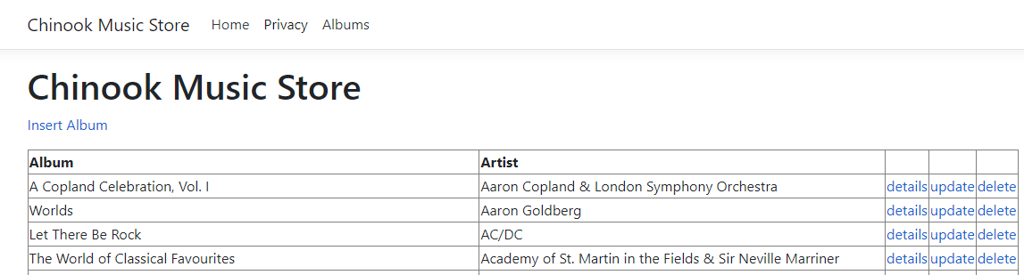

## Insert Album

Selecting ‘Insert Album’ redirects the user to a new page where album information can be entered. The employee can specify the title of the album, the artist and the tracks within that album. The amount of tracks can be modified by selecting either the ‘add’ or ‘remove’ options near the insert button.

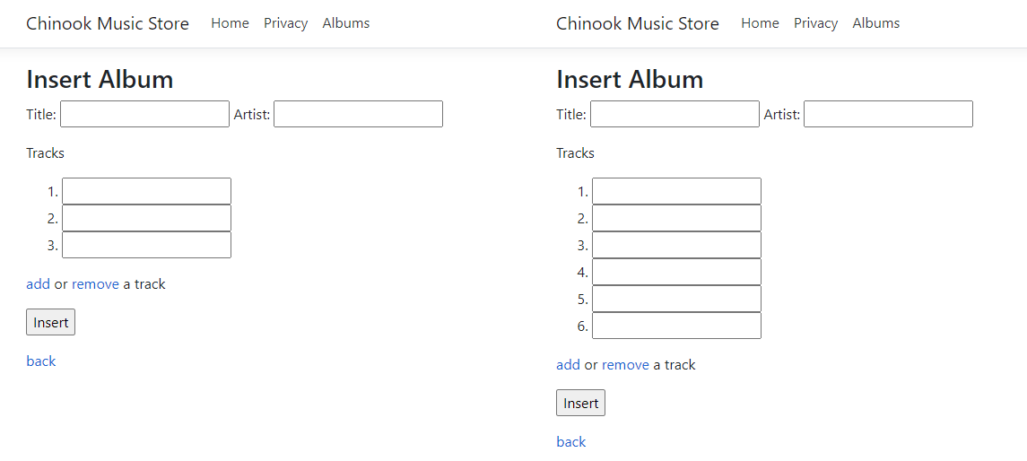

## Details

Selecting ‘details’ displays the album name, artist name and all tracks within the selected album. A return button ‘back’ is provided that redirects the user back to the ‘Albums’ index page.

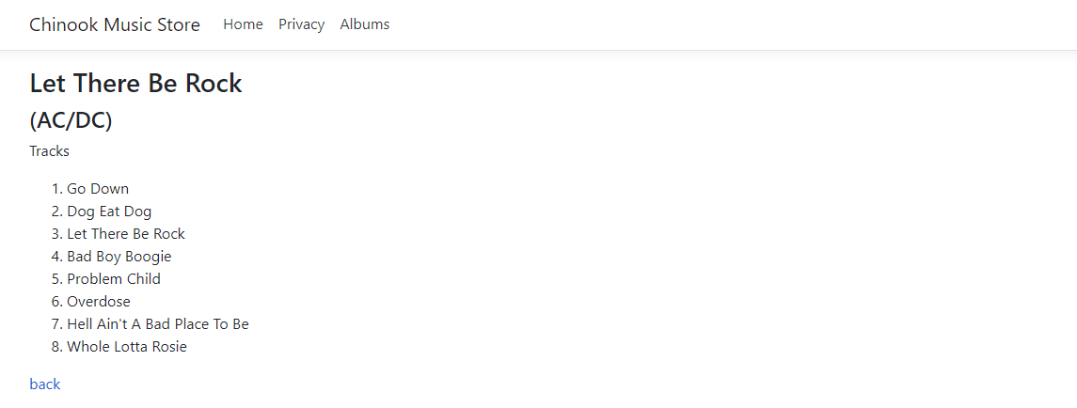

## Update

Selecting ‘update’ displays the same information as ‘details’ but allows the user to modify the data. Currently the album title, artist name and track names can be updated, however the number of tracks cannot be modified yet and the artist can only be chosen from already existing artists.

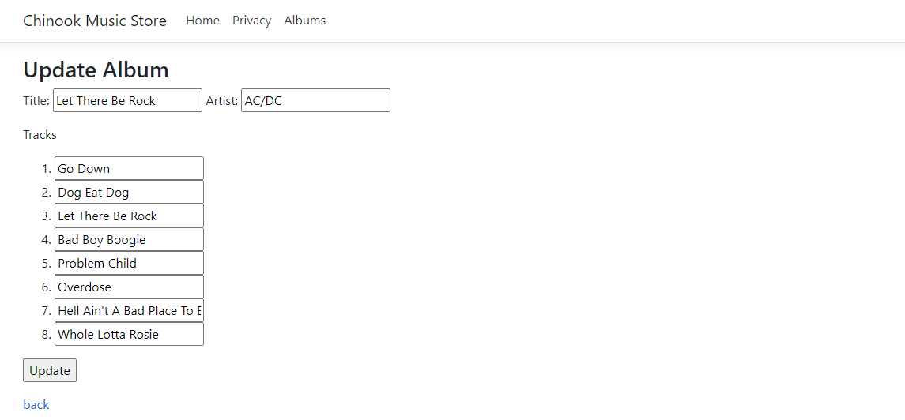

## Delete

Selecting ‘delete’ allows users to delete albums together with their associated tracks. The user is prompted with a confirmation window before deleting any album to confirm the correct selection was made and that deletion was intended.

